Conservation Starters (Erosion)
A narrative shorts comedy web series to engage the general public in conservation and climate topics.


Produced by Tracy Held
Link to Episode

Climate Thoughts (Erosion)
A 34-second vertical shorts comedy web series to engage the general public in conservation and climate topics.
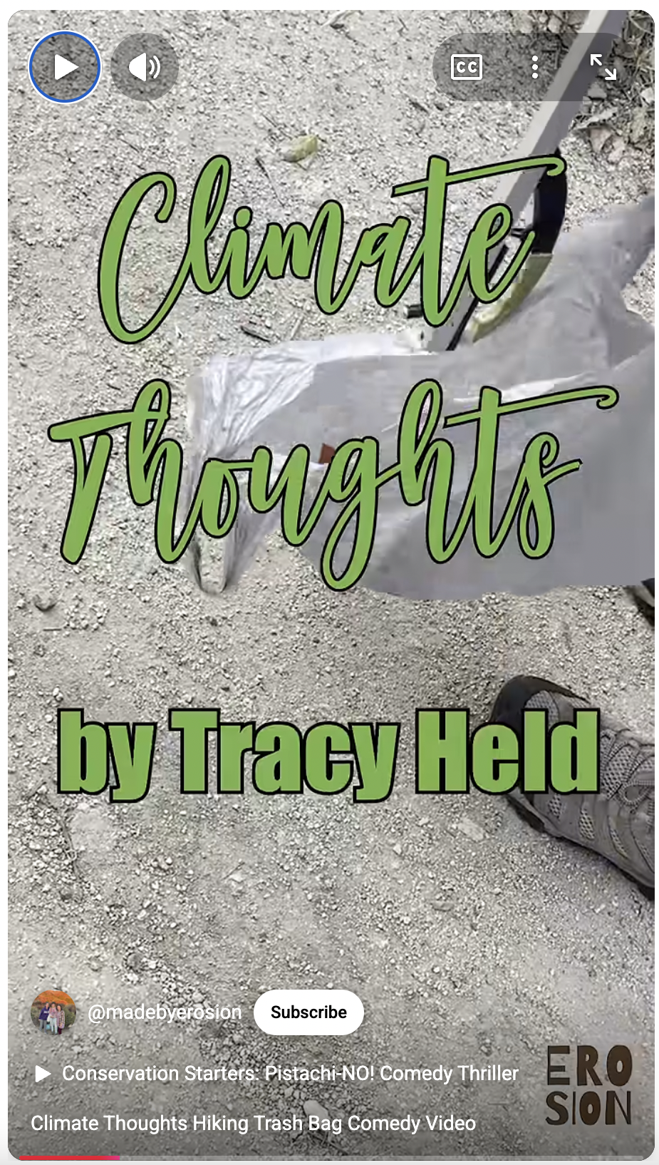  Written & Produced by Tracy Held  Link to Episode | 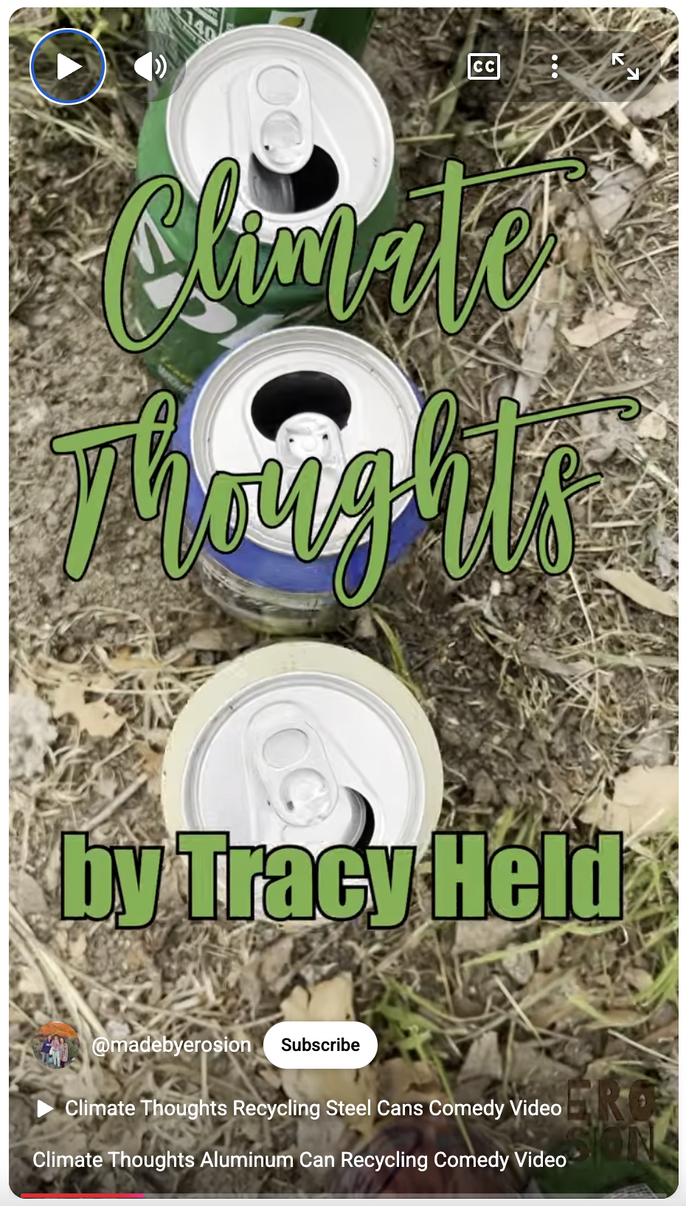  Written & Produced by Tracy Held  Link to Episode | 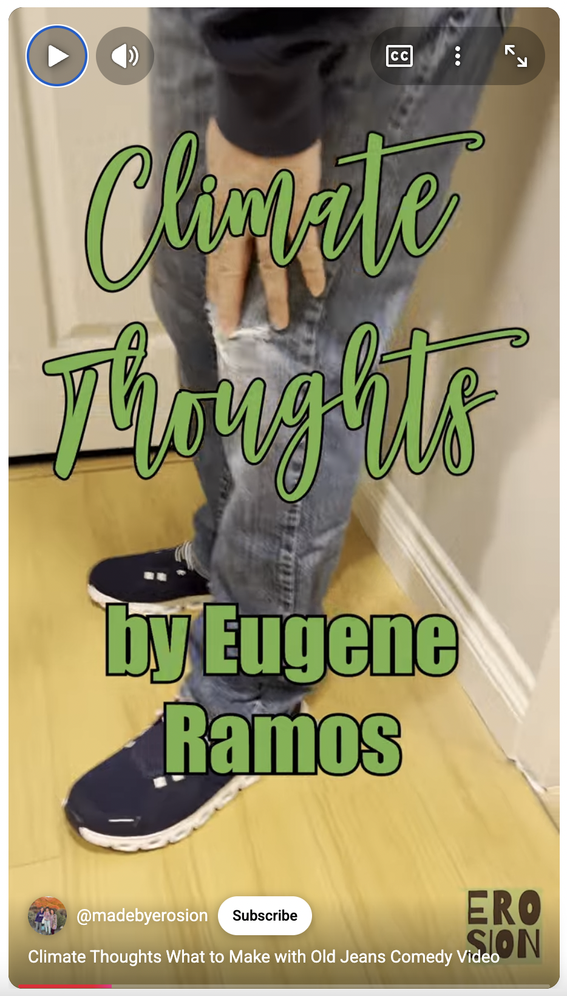  Directed & Produced by Tracy Held  Link to Episode

